Student Name | G. Manasa
Student Registration Number | 241U1R3007 | Class &Section: CSE(DS)
Study Level: UG/PG | UG | Year &Term: I & II
Subject Name | Probability & Statistics

Name of the Assessment | Reflective Journal -5
Date of Submission | 09/07/2025

Reflective Journal Template
Journal Entry Guidelines | Description
1. Experience (Class Content) | Briefly describe the topics or concepts discussed during the class.
2. Feelings (Emotional Reactions) | Share your emotional reactions and thoughts during the class.  How did you feel while learning this theory?  Did the class evoke specific emotions or questions?
3. Learning (Key Insights) | Reflect on what you learned from the class.  Highlight the key insights or fundamental concepts you gained from the class.
4. Application (Practical Use) | Describe how you plan to apply the theory you've learned in real-life situations or in your academic/career endeavours.  Explain the practical utility of this theory.

Sample Journal Entry

Date | 09-07-2025
Journal Entry Topic | Normal Distribution  Characteristics, Applications of Normal distribution.
1. Experience (Class Content) | In this module we discussed about normal distribution. The normal distribution was discovered by karl friedrich gauss the normal distribution is also known as gauusian distribution. Eg height and weight of baby at birth.  A random variable x is said to have normal distribution if its density function or probability distribution $f\left(x, u, σ\right)= \frac{1}{\sqrt[σ]{2π }} e^{\frac{-1}{2}} \left(\frac{x-u}{σ}\right)2$  It is denoted as $X\sim N(u,σ^{2})$ it has two parameters $μ and σ$  And next we discussed about standard normal distribution. The normal distribution with mean of standard deviation 1 is known as standard normal distribution. The random variable that follows this distribution is denoted by z  $$z=\frac{x-μ}{σ}$$  And also we discussed about uses of normal distribution and next importance and applications of normal distribution and next we discussed about its properties at last mam explained problems in the class.
2.Feelings (Emotional Reactions) | When I learned about normal distribution, at first it looked difficult. But soon I understood it is just a bell-shaped curve where most values are near the average and fewer are at the extremes. Knowing its characteristics made it clear and easy. The applications were exciting because it’s used in exam scores, heights, weather, and even quality control. I felt happy to see how this topic connects to real life.
3. Learning (Key Insights) | 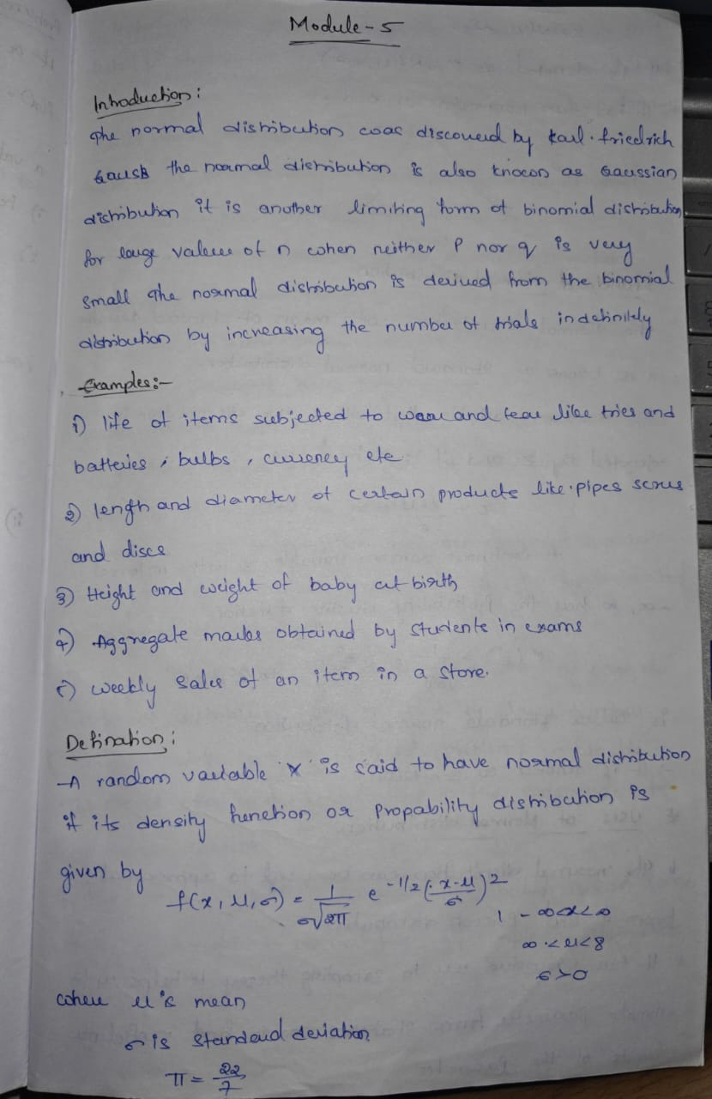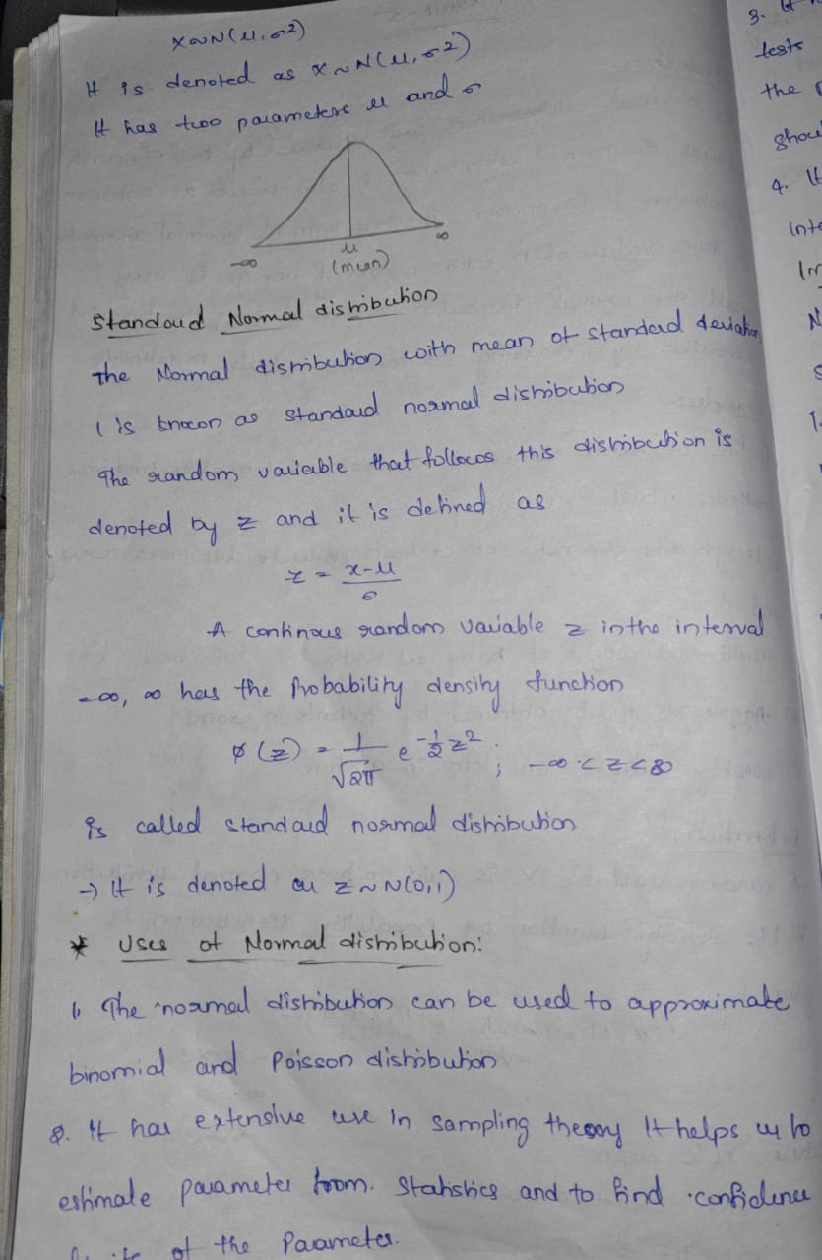  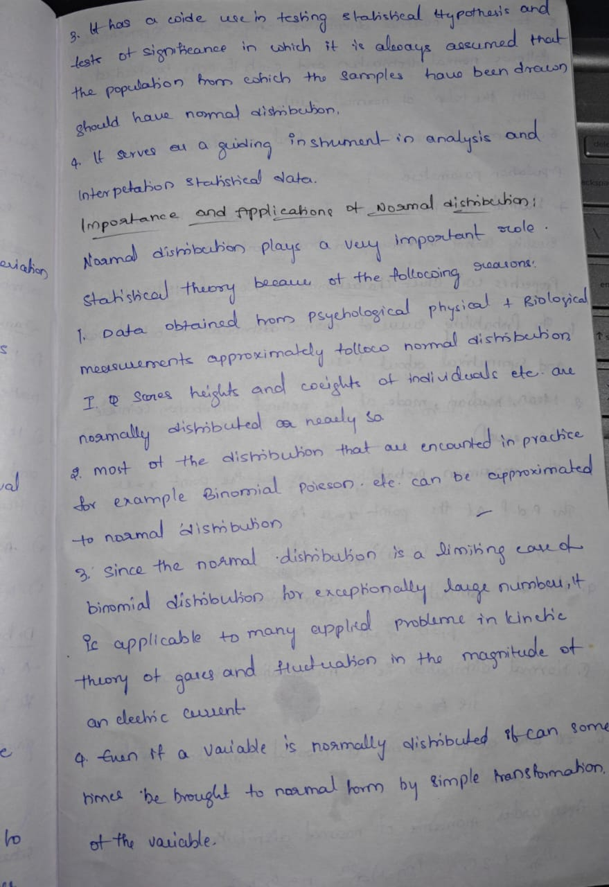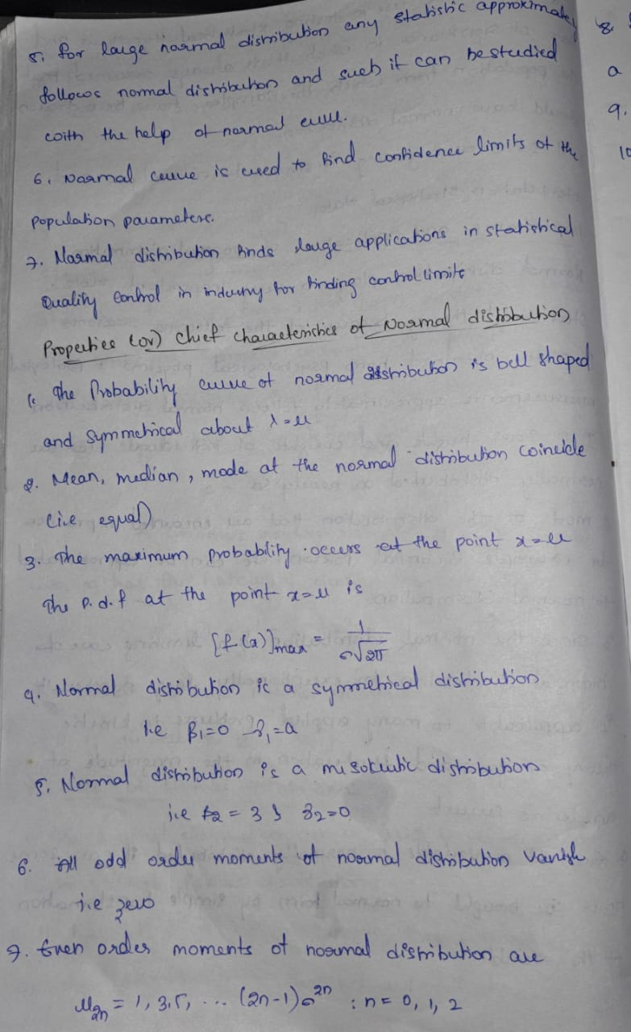  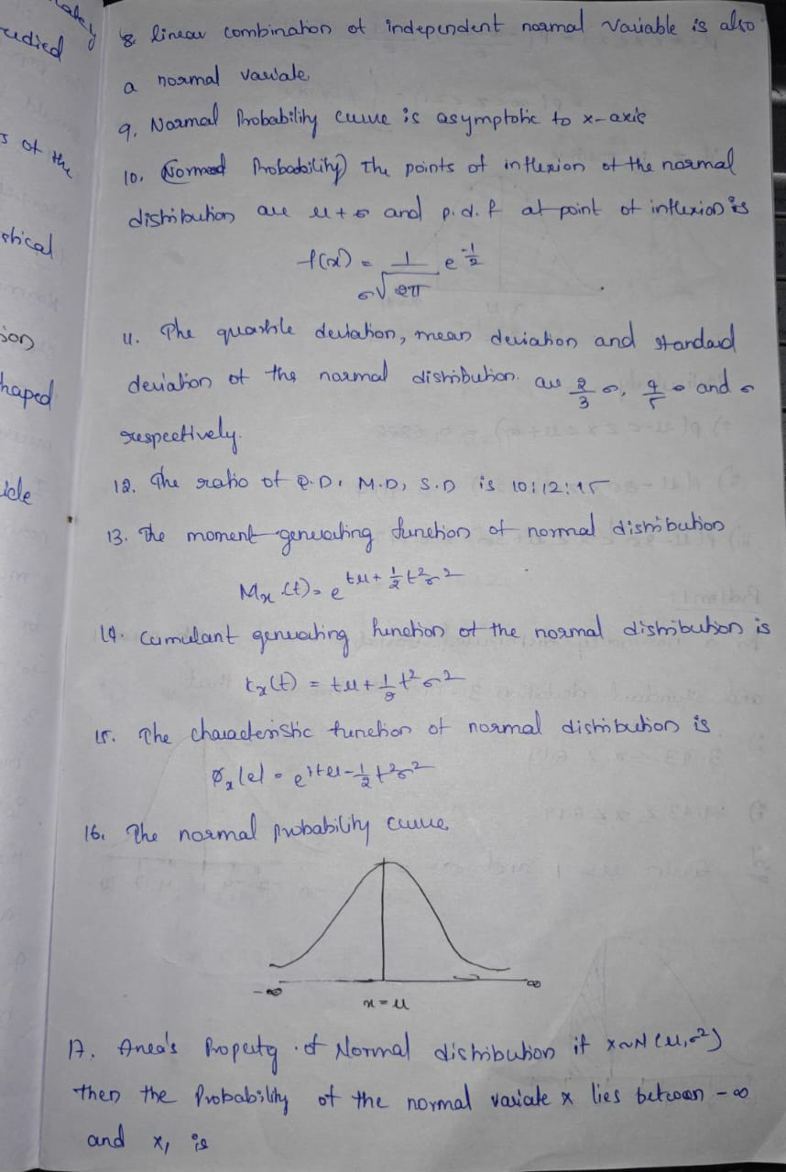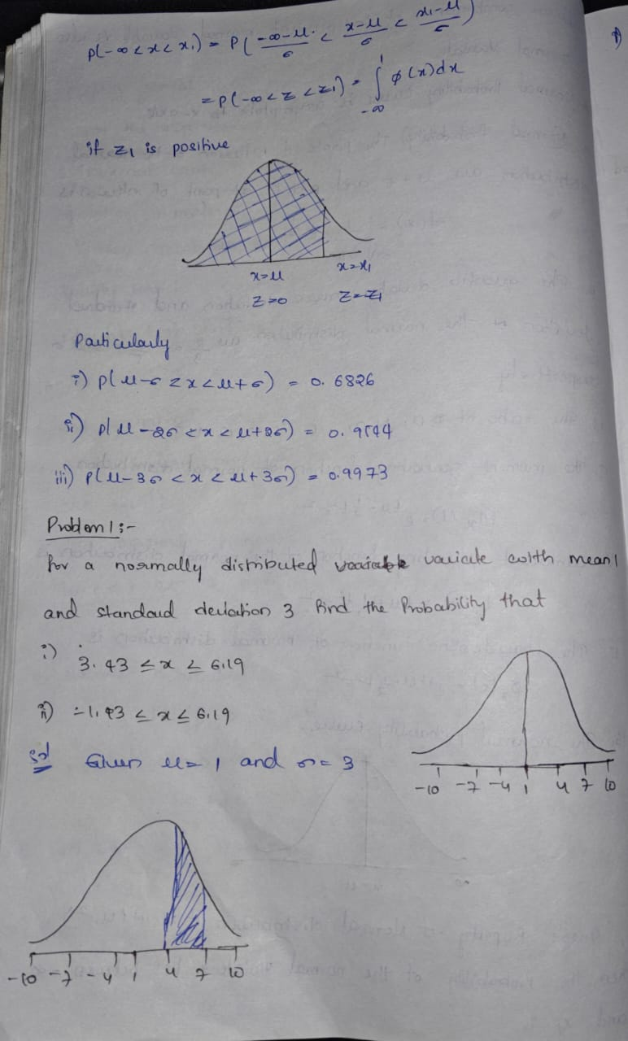  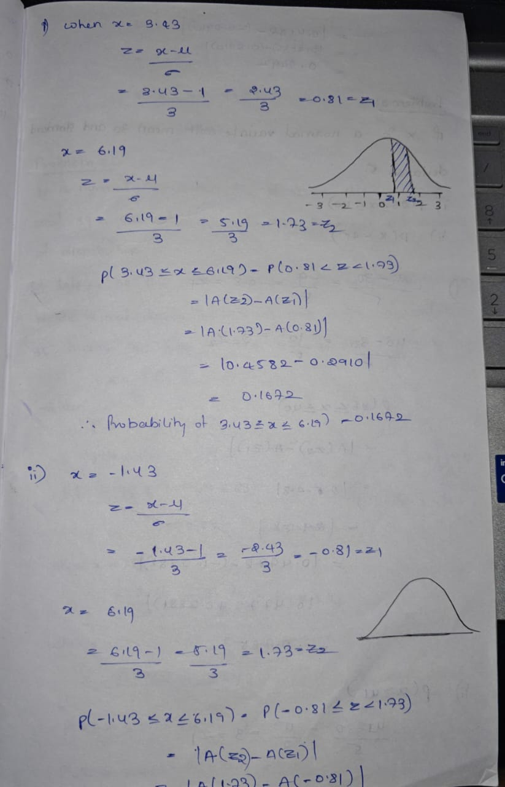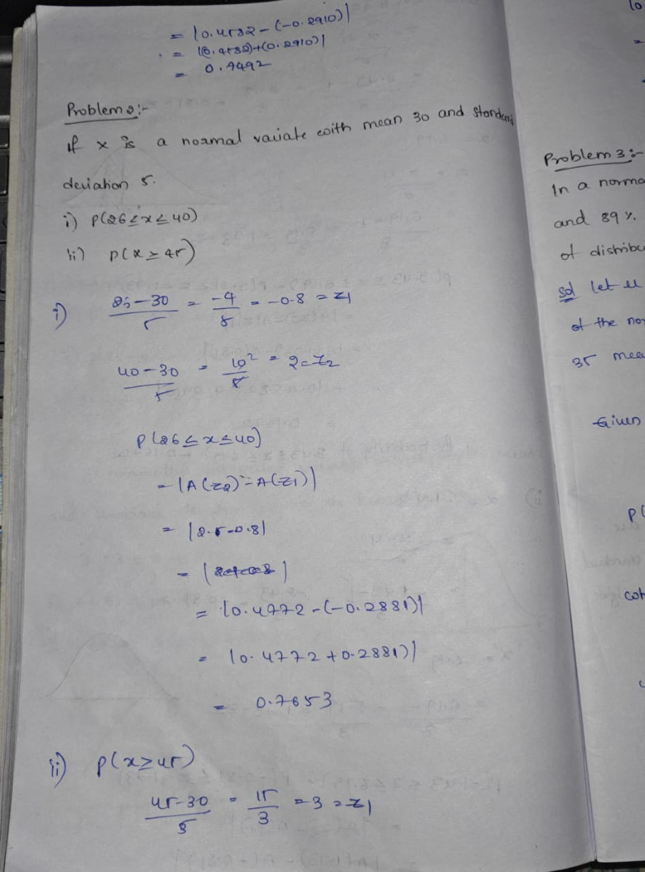  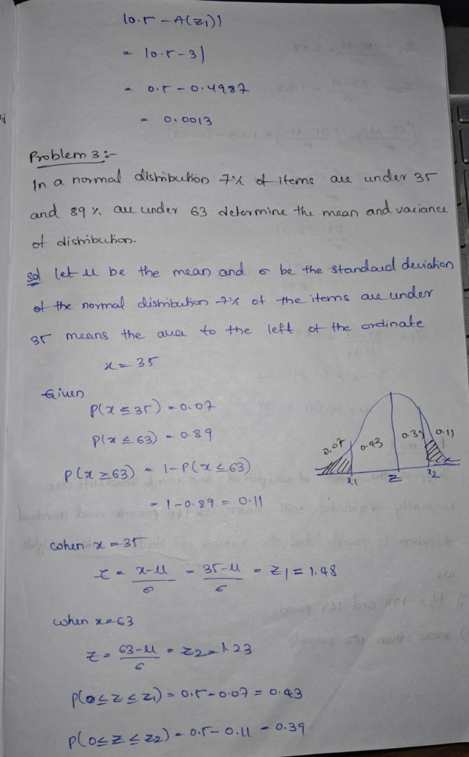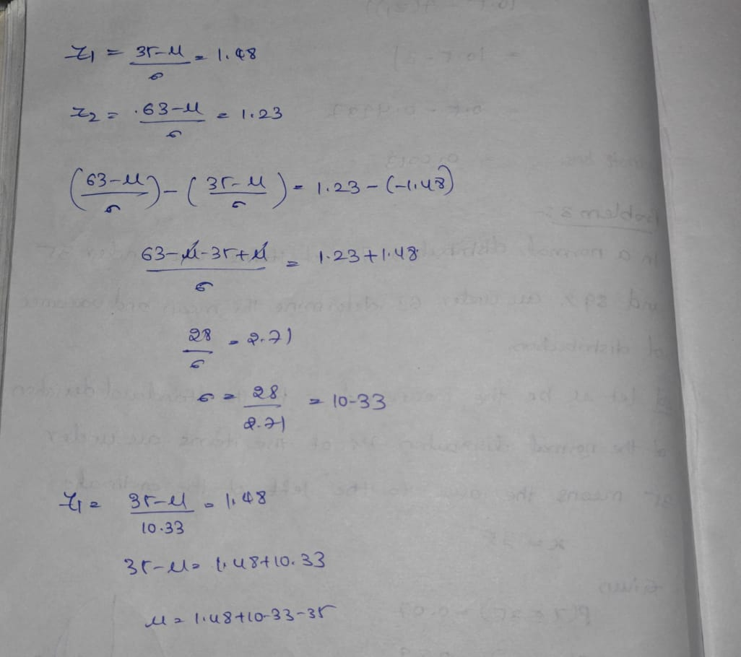
4. Application (Practical Use) | Quality Control in Manufacturing  - Used to check if products meet quality standards.  - Example: Measuring the diameter of machine parts — most will be close to the target size, with very few being too large or too small.  Height and Weight of People  - Human heights and weights often follow a bell-shaped normal curve.  - Example: Clothing and shoe sizes are designed based on these patterns.  Exam Scores  - In large groups, students’ marks usually form a normal distribution — most scores are near the average, with fewer very high or very low scores.  - Helps in grading or setting cut-off marks.  Medical Research  - Used to study measurements like blood pressure, cholesterol levels, or body temperature.  - Doctors can identify abnormal values by comparing them to the normal distribution.  Finance and Stock Market  - Daily stock returns and investment risks are often modeled using normal distribution to predict probabilities of gains or losses.  Measurement Errors  - Errors in scientific experiments often follow a normal distribution, helping researchers analyze data accuracy.  Weather Forecasting  - Temperature changes over a long period often approximate a normal distribution, aiding in climate studies.
Conclusion | In this module, I learned that the normal distribution is an important concept in statistics that appears in many real-life situations. It is a bell-shaped curve where most values are near the average and fewer are at the extremes. I understood its formula, parameters, and the special case called standard normal distribution. I also saw how it is used in quality control, exam scores, medical research, finance, and many other areas. Overall, this topic helped me realize how statistics can explain patterns in the real world and is useful in many fields.

